

Endterm Project

Hotel

Belgibekov Daniyar- 210103372

Dossanov Nurbek- 210103158

Orzhanov Nauryzbek-210103169

Database Management 2

Introduction

The database project for the hotel is an important component of commerce, which provides storage of information about customer numbers, booking, payment. This allows you to manage all aspects of the hotel's activities.

An ER diagram is a graphical representation of objects and the relationships between them. In the project, the ER diagram allowed us to understand what data needs to be stored and how they relate to each other. This made it possible to determine the correct database structure and correctly distribute information across tables.

Table normalization is a database optimization process that avoids redundant and contradictory information. In the project, we used three forms of normalization, which allowed us to reduce the size of the database and improve its performance.

Triggers are software modules that are automatically triggered by certain user actions. In the project, we used triggers to automatically update information in the database with certain actions of the client or administrator, which increased the usability of the system.

As a result of our work, we have created a database that allows us to efficiently store, process and manage hotel data. This allows you to reduce the time and cost of processing reservations, as well as improve the quality of customer service.

Overview

ER diagram

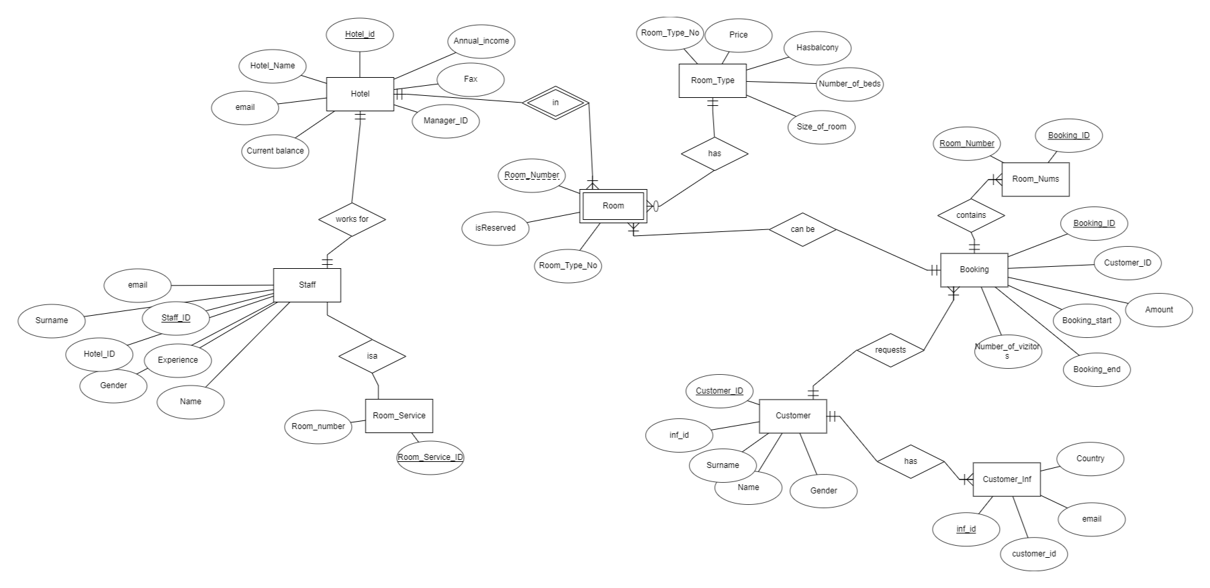

Relationships:

1) Hotel has room  
One to many

2) Staff works for hotel

One to one

3) Staff have room_service  
One to many

4) Room have room_type  
Many to one

5) Room can be Booked

Many to one

6) customer requests booking

One to many

7) Customer have customer_inf

One to many

Normalization

Table Hotel:

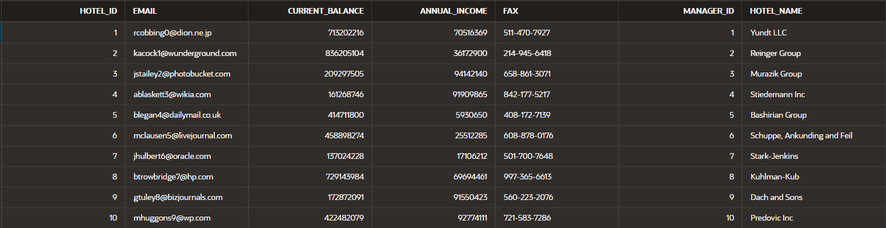

Table Staff:

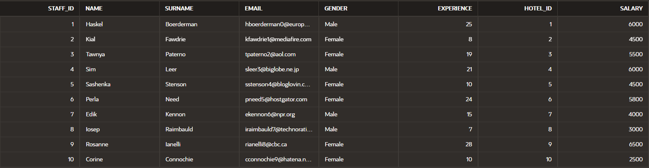

Table Room:

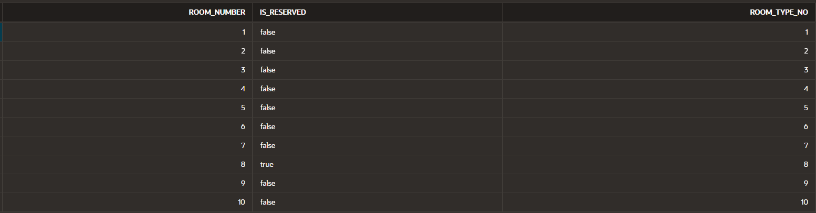

Table Room_type:

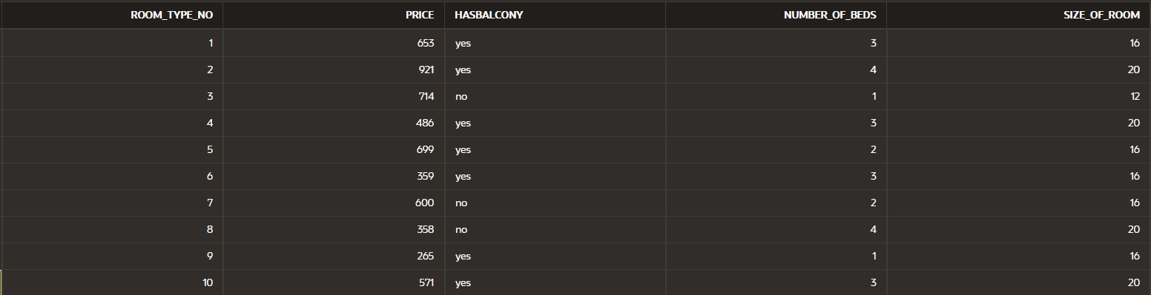

Table Customer:

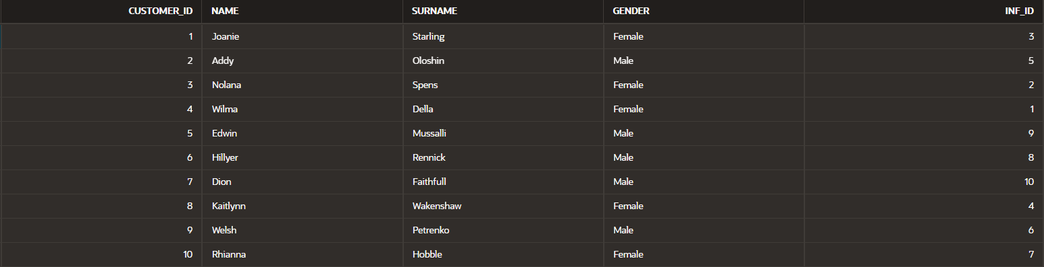

Table Booking:

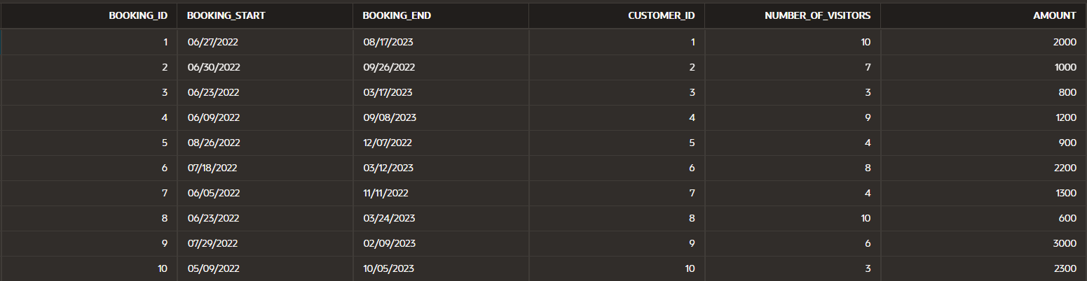

Table Room_nums:

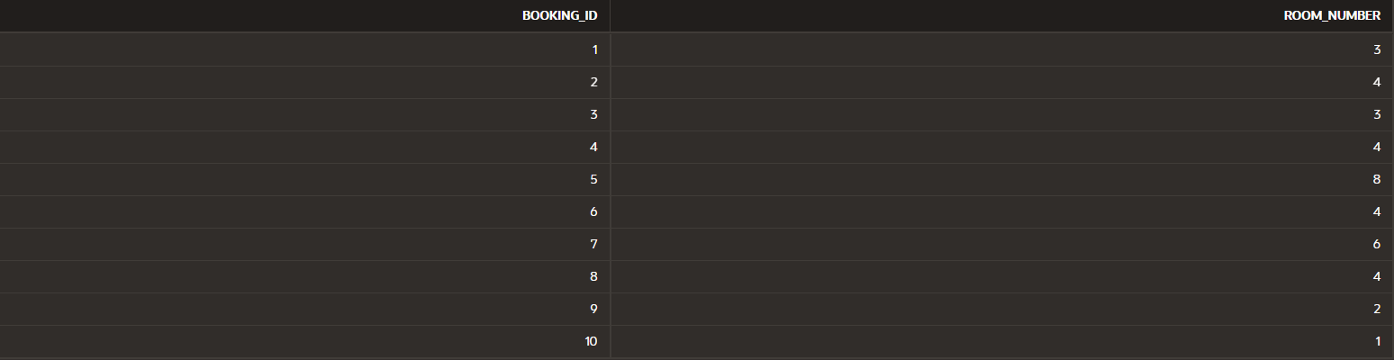

Table Customer_inf:

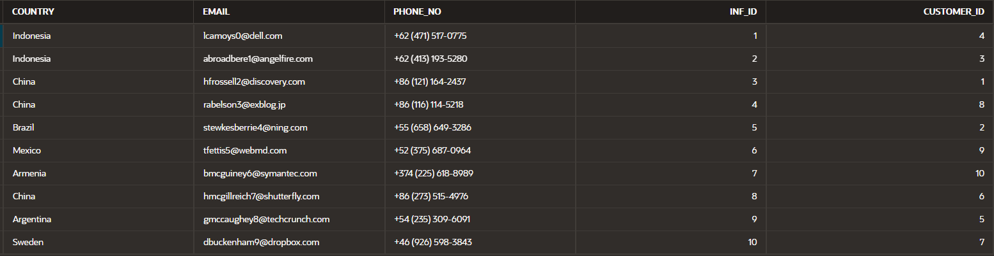

Table Hotel.

**Hotel_id** (primary key) -> {email,current_balance,annual_income, fax, manager_id, hotel_name}

Table Staff.

**Staff_id** (primary key) -> {name,surname,emil,gender,experience,hotel_id,salary}

Table Room**.**

**Room_number**(primary key) -> {is_reseved, room_type_no}

Table Room_type.

**Room_type_no** (primary key) -> {price,hasbalcony, number_of_beds, size_of_room}

Table Customer.

**Customer_id** (primary key) -> { inf_id, name, gender, surname}

Table Booking.

**Booking_id**(primary_key) -> {customer_id,amount,booking_start,booking_end, number_of_visitors}

Table Customer_inf.

**Inf_id**(primary_key) -> {country, email, customer_id}

**Functions & Triggers**

**1) Procedure which does group by information**

**CREATE OR REPLACE PROCEDURE group_inform AS**

**CURSOR select_sal IS**

**SELECT salary, COUNT(*) AS emp_count**

**FROM staff**

**GROUP BY salary;**

**BEGIN**

**FOR i IN select_sal LOOP**

**DBMS_OUTPUT.PUT_LINE(i.salary i.emp_count );**

**END LOOP;**

**END;**

**BEGIN**

**group_inform;**

**END;**

**2) Function which counts the number of records**

**CREATE OR REPLACE FUNCTION count_records(table_name VARCHAR2) RETURN NUMBER IS**

**count_num NUMBER;**

**BEGIN**

**EXECUTE IMMEDIATE 'SELECT COUNT(*) FROM ' table_name INTO count_num;**

**RETURN count_num;**

**END;**

**DECLARE**

**counter NUMBER;**

**BEGIN**

**counter := count_records('hotel');**

**DBMS_OUTPUT.PUT_LINE(counter);**

**END;**

**3) Procedure which uses SQL%ROWCOUNT to determine the number of rows affected**

**CREATE OR REPLACE PROCEDURE update_employee_salary IS**

**BEGIN**

**UPDATE hotel**

**SET annual_income = annual_income + 5000**

**WHERE hotel_id > 3;**

**IF SQL%ROWCOUNT > 0 THEN**

**DBMS_OUTPUT.PUT_LINE(SQL%ROWCOUNT);**

**END IF;**

**END;**

**select * from hotel;**

**begin**

**update_employee_salary;**

**end;**

**4) Add user-defined exception which disallows to enter title of item (e.g. book) to be less than 5 characters**

**DECLARE**

**hotel_name VARCHAR2(50) := 'Rixos';**

**error_length EXCEPTION;**

**BEGIN**

**IF LENGTH(hotel_name) < 5 THEN**

**RAISE error_length;**

**ELSE**

**DBMS_OUTPUT.PUT_LINE('Вот енды норм');**

**END IF;**

**EXCEPTION**

**WHEN error_length THEN**

**DBMS_OUTPUT.PUT_LINE('Брат бестен аз болып калды');**

**END;**

**5) Create a trigger before insert on any entity which will show the current number of rows in the table**

**CREATE OR REPLACE TRIGGER count_r BEFORE INSERT ON hotel**

**DECLARE row_count NUMBER;**

**BEGIN**

**SELECT COUNT(*) INTO row_count FROM hotel; DBMS_OUTPUT.PUT_LINE('Саны ' || row_count);**

**END;**

**insert into hotel(hotel_id, email, current_balance, annual_income, fax, manager_id, hotel_name) values(12, 'asfasf@gmaol.com', 2345,13245,222-111-2244, 12, 'dadae');**

Conclusion

As a result of the implementation of the database project for the hotel, our team has developed a reliable and efficient data management system that allows you to store, process and manage information about booking and rooms.

The ER diagram allowed us to understand what data needs to be stored and how they relate to each other. This helped us to determine the correct database structure and correctly distribute the information across the tables.

Normalization of tables helped to optimize the database and improve its performance. Triggers provide automatic updating of information in the database at certain actions of the client or administrator, which increases the usability of the system.

The database developed by our team allows you to effectively manage hotel data, reducing the time and cost of booking processing and improving the quality of customer service. We hope that our work will be useful and successful for the development of our client's business.

GitHub(https://github.com/Nurbek004/DBMS_project)